Anglova Scenario
The Anglova Scenario has been developed as part of the NATO IST-124 Research Task Group on Heterogeneous Networks: Improving Connectivity and Network Efficiency. This is an emulation scenario specifically developed for experimentation over emulated tactical networking environments.
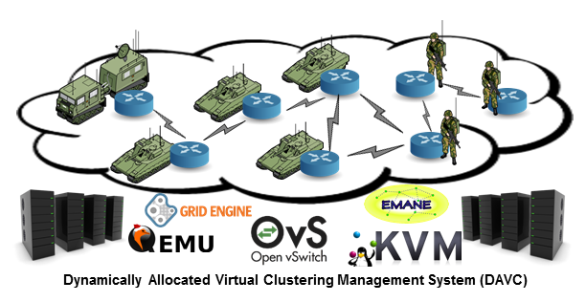
The scenario is developed for the EMANE Network Emulation environment and consists of three vignettes:
- Intelligence Preparation of the Battlefield
- Troop Deployment
- Neutralization of Insurgents and IEDs and Medical Evacuation
At the moment, the troop deployment vignette (2) is the first one available for download and consists of detailed movement and pathloss parameters for a battalion-sized deployment.

Vignette 2: Troop Deployment
Clicking on the following links allows you to download the movement data as and the calculated pathloss data for both a 50MHz (narrowband) waveform as well as for a 300 MHz (wideband) waveform.
- LatLong.7z
- PathLoss-50MHz.7z
- PathLoss-300MHz.7z
Java-based applications that read the above position and pathloss data and generate events that drive an EMANE simulation can be downloaded here:
- AnglovaDriver
- AnglovaGUIDriver
The first one is a text application whereas the second one has a Graphical User Interface.

Map data
Map data can be accessed using following instructions.

Publications
For more details, please see the following papers published at the IEEE ICMCIS 2016 and 2018 Conferences. Clicking on the papers below will take you to the paper in the IEEE Digital Library. These are also the most recent papers about this scenario, so if you happen to use the scenario, please cite the following papers.
Suri, N., Hansson, A., Nilsson, J., Lubkowski, P., Marcus, K., Hauge, M., Lee, K., Buchin, B., Misirlioglu, L., and Peuhkuri, M. A Realistic Military Scenario and Emulation Environment for Experimenting with Tactical Communications and Heterogeneous Networks. In Proceedings of the IEEE International Conference on Military Communications and Information Systems (ICMCIS 2016), Brussels, Belgium, May 23rd-24th, 2016.
Suri, N., Nilsson, J., Hansson, A., Sterner, U., Marcus, K., Misirlioğlu, L., Hauge, M., Peuhkuri, M., Buchin, B., Velt, R. in 't , Breedy, M.. "The angloval tactical military scenario and experimentation environment." 2018 International Conference on Military Communications and Information Systems (ICMCIS). IEEE, 2018.

Anglova Scenario Used in Scientific Publications
Scenario has been used in publications listed on papers page.
We would love to hear if Anglova Scenario has been useful. Why not send email and tell us.

